UI Prototypes

These are the UI prototypes for the phone, most of these will be reused for many pages

Log In Tables to Grid Conversion

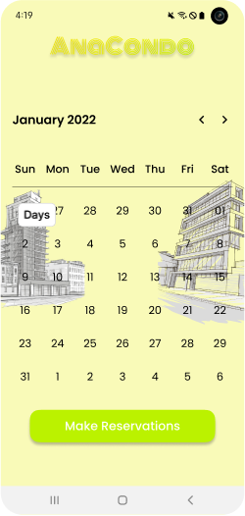

Message Board

